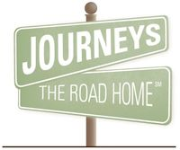
Reaching Out to Those in Need in Our Community
“He who oppresses the poor taunts his Maker, but he who is gracious to the needy honors Him.” Proverbs 14:31

www.journeystheroadhome.org
847-963-9163
1140 Northwest Highway,Palatine,IL

Journeys - The Road Home is a proud member of the Alliance to End Homelessness in Suburban Cook County, a non-profit organization responsible for planning and coordinating homeless services and housing options for all of Cook County outside of Chicago.

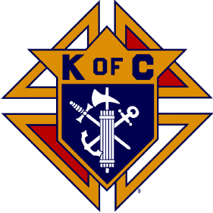

Holy Rosary Council and Journeys Partnership
Campaign September 1-November 16, 2017

You can help us over the next few months by donating

Travel Size Shampoo
Travel Size Shower Gel
Easy to Prepare Foods (Mac n Cheese, Campbell soups, Ramen Noodles etc)
Women’s Underwear (new)
Gym Shoes sneakers (new or gently used)
Or Cash Donations

Bring all donations to the hall where we will have a box for Journeys in the office.
Questions call Randy Baker at 847.255.6503 or email at rlbaker27@gmail.com

